NURAGRID  
TECHNICAL DATA SHEET

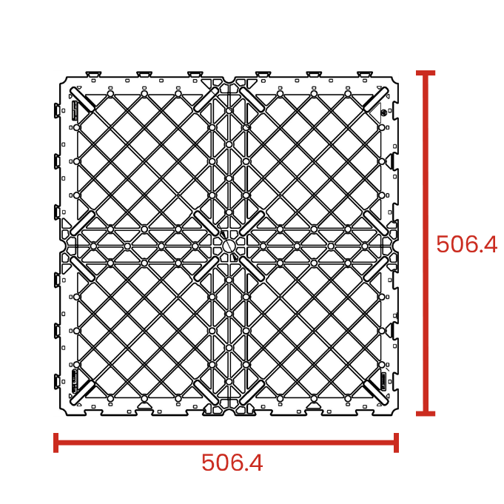

# TECHNICAL SPECIFICATION

The safety grid is made up of a panel measuring 50 x 50cm and 4cm high, produced with black thermoplastic polymer. The purpose of this panel is to create a sub-floor on which various types of flooring can be directly laid, such as porcelain stoneware, marble, stone, etc.  
  
The grids are placed side by side and linked to each other by means of the “dovetail” joints arranged along the entire perimeter, thus forming a continuous and robust surface.  
  
The system is completed with the coupling of height-adjustable supports (PRIME ®, SE, NM, SB) whose head rests on the intrados of the panels in the special slots provided in the corners, in the center of the panel and along the edges side.  
  
If you want to obtain a more robust substructure, we recommend adding a support in the center of the grid and along the four side edges. The safety grid must be applied outdoors. In the case of laying with porcelain stoneware slabs or other types of slabs, we recommend using the following accessories.

* DM spacer with no aglet, 4 mm thick
* LGH leveler, diameter 110 mm
* Cross spacer 15 mm high, thickness 2 – 3 – 4 mm
* Perimeter spacer in stainless steel or PP

**RAW MATERIAL:** Polypropylene

**ENVIRONMENTAL IMPACT:** Recyclable material – not dangerous

GENERAL CHARACTERISTICS & PROPERTIES

|  |  |  |  |
| --- | --- | --- | --- |
|  | **Unit** | **Value** | **Tolerance +/-** |
| **Body width** | cm | 50.6 | +/- 0.5 |
| **Body height** | cm | 4 | +/- 0.2 |
| **Bearing surface** | cmq | 2500 | +/- 2 |
| **Weight** | kg | 2.9 | +/- 0.05 |
| **Shore** | shore d | 70 | +/- 3 |
| **Maximum flexion\*** | % | 1 | - |
| **Low T(°C) reaction** | °C | -40 | - |

*To reduce the degree of flexion, it is recommended to add a support in the center of the grid.

ITEMS CHARACTERISTIC & PROPERTIES

|  |  |  |  |
| --- | --- | --- | --- |
| **COD.** | **Description** | **Measure** | **Pcs. Per Box** |
| NJNG | Nuragrid Safety Grid | 50.6 x 50.6 x 4 cm | 200 |

INSTALLATION INSTRUCTIONS

1. Place the supports on the laying surface and adjust them to the desired height;
2. Place the grid panels onto the supports in correspondence with the special slots provided and bring the panels closer to each other through the “dovetail” couplings;
3. Check that the continuous surface obtained is perfectly flat, use the adjustment key if needed;
4. Lay the flooring elements (porcelain stoneware, marble, stone, etc.) taking care to position the MINI DM spacer with no aglet to create the “joint” and then align all the elements. The LGH leveler, 1 or 2 mm thick, has the function of levelling particular situations. The cross spacers 15 mm high can be used as an alternative to the MINI DM spacer. It has the function of creating the “joint” and aligning the flooring elements as well. Along the perimeter edges, use the special stainless steel or PP perimeter spacer.

The final packaging of the pallets is made with the wrapping of a polyethylene film. Indoor storage.

The above data are relevant to current production and may be changed or updated by Eterno Ivica at any time without notice. Given the many possible uses and the possible interference of external elements, we do not assume responsibility for the results. The buyer is required to establish under their own responsibility, the suitability of the product for the intended use.